On the Other Side - a performative concert
COMPAGNIE
Jubilo
30 minutes, English

SYNOPSIS
On the Other Side, is a new work process opened by Jubilo in 2018. It is an attempt to investigate the moment of passage from the state of imprisonment to the state of freedom questioning the deep meaning of these 2 words. How and in which way we pass the border between inprisonment and freedom? Is this border clear? How far is it from us?

The first stage of the research process, which will be presented, is the work on musical materials devised and composed on the piano by Dawid Ilczyszyn in collaboration with Diego Pileggi. It is an attempt to translate through music the different aspects of the passage from one condition to another. From the first step on the other side of the border to the perception of the “new world” painted and described as free.

The figure of Kaspar Hauser has been accompanying the artists in this journey, trying to reinterpret and witness anew a reality in continuous change, giving new lenses to perceive our world and at the same time questioning it from a different perspective, the one of the “outsider”.

ABOUT THE COMPANY
Jubilo is an international theatre group, born in 2011 in Wroclaw, Poland. The name draws from the Latin roots of the word ‘jubilare’, meaning ‘to shout with joy.’ The starting point of Jubilo’s work is the need for artistic intervention against social exclusion within society. In the fabric of every community, there are marginalized peoples living on the borders or invisibly within society, due to socio-economic exclusion, race/ethnicity, or developmental disabilities. This marginalization between peoples within a community leads to the breakdown of human relations, conflicts, and ultimately the building of walls between different groups.

Jubilo aims to disintegrate these social, economic, language and cultural barriers through the action of artistic encounters, where the platform of exchange is the theatrical language of body, voice and music. From this language we build a common vocabulary, through which personal relations are deepened between each person of the group of reference. These encounters are realized through a series of long-term workshops.
CONTACT
http://jubiloproject.com/en/
Documentary : https://www.youtube.com/watch?v=4taPxAA34Tg

L’AFFICHE

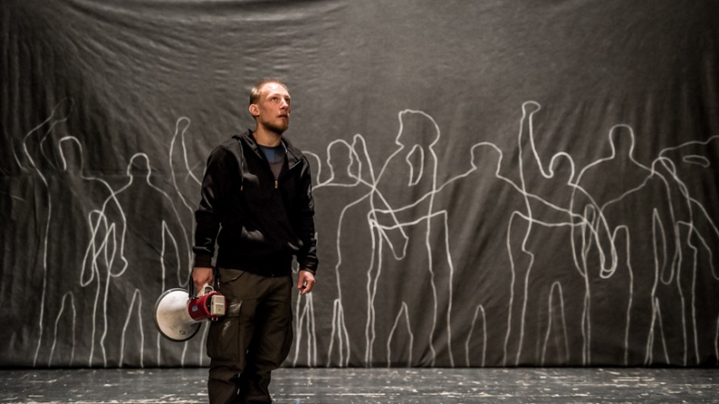
23: JUBILO WORK PRESENTATION (film and discussion - 1H20)
Work presentation of the project “Unlocking”, held in the Penitentiary Prison n.1 of Wroclaw

From 2014 Jubilo is leading “Unlocking”, theatre project addressed and developed with inmates of the Penitentiary Prison n.1 of Wroclaw. During these two years, a working group has been established inside the penitentiary. With this group, the actors of Jubilo opened a theatre research process that gave birth, in November 2015 to the performance “Odzwierciedlenie” (Reflection).
During this work presentation, a short documentary as well as pictures captured during the rehearsing process, will give the possibility of opening a discussion about the experience of the group throughout this period and the approach used in building the performance. The project Unlocking is still in development.

Lenght: 60/90 min
About the project : http://jubiloproject.com/unlocking-kleczkowska-prison/
A Propos de la Compagnie:

AFFICHE :

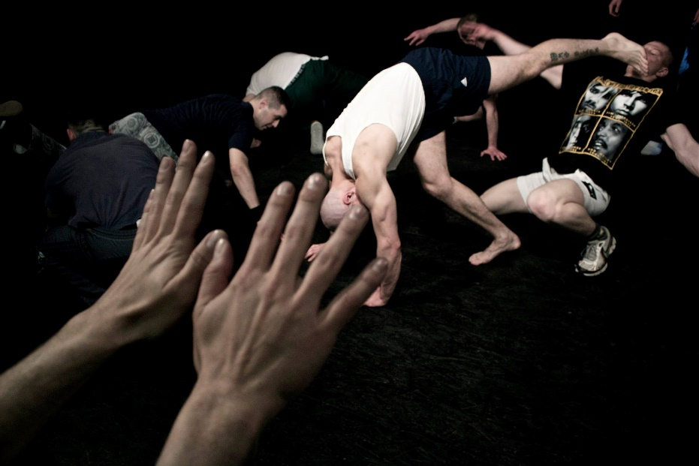

24: Workshop
IAM . Here. Now. I Speak. To you.
Masterclass led by Diego Pileggi. Assisted by Dawid Ilczyszyn.

This work session will focus on the theme of Identity.
Our initial steps in the workshop will focus on technical elements of theatre craft. From there we will slowly move to the second phase of the work: searching to transcend craft in a creative process directed towards the underlying theme of the workshop.
Why do we stand on stage? What is our need to speak, and then what do we say? How do we fulfil the potential of our words, and our actions, on stage? These questions, connected directly to the identity of the person/actor, will accompany us to a place where an act of expression is truthful and without apology.
Since 2011 Jubilo develops theatrical work with groups in disadvantaged conditions or those defined as being on the border of society. With this masterclass we will try to build a thematic, physical and creative bridge with the projects the company has been developing in the last years. The participants will have in this way a possibility to actively relate to the work of Jubilo, learn and develop technical elements, as well as question themselves creatively.
Technical elements developed in the masterclass:
- Group Dynamics/Ensemble work
- Partnership exercises
- Basic elements of acrobatics
- Body/Voice work
- From text to a physical partiture
Max. 20 participants
Lenght: 3 h

Diego Pileggi is an Italian actor and director. He obtained an MA in Acting from the postgraduate drama programme of Manchester Metropolitan University, run in collaboration with Song of the Goat Theatre (2011) and a degree in Performative Arts from Università degli Studi di Milano (2007). He is a founding member of Odra Ensemble (2012), a physical theatre company run in collaboration with Song of the Goat Theatre, and of Italy-based theatre company Il Giardino delle Ore (2010). Diego Pileggi is the leader of Oistros, a theatre research expedition focused on the south Italian ritual of Tarantismo, as well as on traditional work/liturgical songs and knife fight. Since 2012 he has been a founding member and leader of Jubilo Foundation, a theatre company that develops work with groups marginalised by society. With Jubilo he has given workshops, directed and developed theatre projects in different milieus including adults with mental and physical disabilities, Polish/Roma youth, refugees, youvenile criminals and prisoners.
The performance Reflection, outcome of the project, in 2017 won the 4th National Competition of Prison Theatre Art in Poznan (Pl) and received Grand Prix of the 26th National and 14th International Review of Prison Art in Sztum (Pl).
Dawid Ilczyszyn
Born in Poland in 1990. Since his childhood he played the piano but he abandoned it for years. In 2014 he started participating in the project Unlocking lead by Fundacja Jubilo re-discovering his passion and developing his work with music. In 2015 Jubilo premiered the performance Reflection into which Dawid plays his authorial music.
Dawid is a technician of the Grotowski Institute in Wrocław, Poland.

